PRACTICAL 1...

/* Display the factorial of the entered number using Function Recursion*/

#include<iostream.h>

long facto(int a);

void main()

{

int a;

long b;

cout<<"Enter a number: ";

cin>>a;

cout<<endl;

b=facto(a);

cout<<a<<"! = "<<b;

}

long facto(int a)

{

if (a==0)

return 1;

else

return (a*facto(a-1));

}

OUTPUT... 1

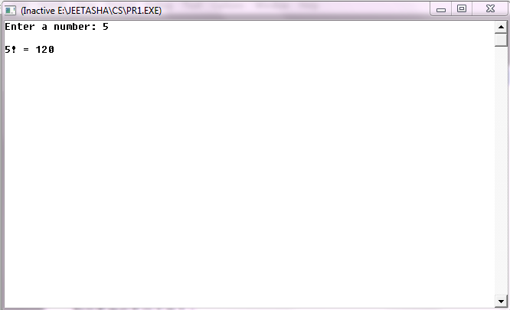

PRACTICAL 2...

/* A program to print the reverse of the entered String*/

#include<iostream.h>

#include<stdio.h>

#include<string.h>

void main()

{

char AB[50];

cout<<"Enter the string: \n";

gets(AB);

strrev(AB);

cout<<"\n\n The 'REVERSE' of the given string is: \n";

puts(AB);

}

OUTPUT 2

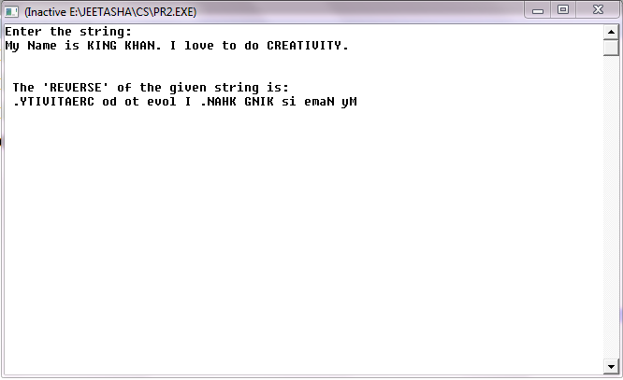

PRACTICAL 3...

/* Write a program to display a costumer class with the following specifications:

Private members:

* c_name 25 characters
* address 25 characters
* city 15 characters
* state 2 characters
* balance double

Public Members:

* void input_data To enter the costumer class attributes
* void output_data To print the costumer class attributes*/

#include<iostream.h>

#include<stdio.h>

class costumer

{

char c_name[25],address[25],city[15],state[2];

double balance;

public:

void input_data()

{

cout<<"Enter the name of the costumer: ";

gets(c_name);

cout<<"\nEnter the Address: ";

gets(address);

cout<<"\nEnter the city of the costumer: ";

gets(city);

cout<<"\nEnter the state of the costumer: ";

gets(state);

cout<<"\nEnter the amount: ";

cin>>balance;

}

void output_data()

{

puts(c_name);

puts(address);

puts(city);

puts(state);

cout<<balance;

}

};

void main()

{

costumer cls;

cls.input_data();

cout<<"\n\n\n";

cls.output_data();

}

OUTPUT 3

